**Case of UCO Bank ,Main Branch,Shimla**

**07.10.2020**

**The Asst. General Manager**

**UCO Bank, Sector-17B, Chandigarh VALUER REPORT UID NO.:CEV/RVO/299/0291/07102020**

**VALUATION REPORT ( IN RESPECT OF LAND / SITE AND BUILDING)**

|  |  |  |  |  |  |  |  |  |
| --- | --- | --- | --- | --- | --- | --- | --- | --- |
| **I** | General | |  | |  | | | |
| 1. | Date and Time of Inspection | |  | | 03.10.2020 **at 1.00 PM** | | | |
| 2. | Purpose for which valuation is made | |  | | Take Over Loan From India Bulls Finance Ltd. | | | |
| 3. | Name of the Bank for which valuation is made | |  | | UCO Bank | | | |
|  | Address of the property to be valued | |  | | **Flat No. 92-C, Highland Park, (Third floor), High Land Marg,Vill. Bhabat, Zirkpur,Distt Mohali (PB) Pincode- 160003** | | | |
| 4. | Owner’s & Borrowers’ Name and Address | | : | | Smt. Santosh Thakur w/o Sh. Ghanshyam Thakur r/o Vill. Majhar(287), Durgapur, Shimla **, (Himachal Pardesh**)  **Pincode-171007** | | | |
| 5 | List of the documents handed over to the Valuer by the branch | | : | | Sale deed of Flat dt 10.05.2019 | | | |
| 6 | Details of the enquiries made/visited to the Govt. offices | | : | | Inquiries made from local property dealers and searches made from real property web sites like **“99acres.com,magicbricks.com&makaan.com”** and screen shots of the same taken and appended with the valuation report for ready reference of the bank. | | | |
| **II.**  **Property Details**  - | | | | | | | | |
| 1. | If the property is under the joint ownership/co-ownership share of the such owner/undivided | |  | | Single ownership | | | |
| 2. | Brief description of the property (whether open land, House property, land area, built up area, no. of floor etc.) | |  | | **Flat No. 92-C, Highland Park, (Third floor), High Land Marg,Vill. Bhabat, Zirkpur, Distt Mohali (PB) Pincode- 160003** . | | | |
| 3. | Dimensions of site  **Lats. 300 38’55”N & Long. 760  47’49”E** | |  | | As per deed | | Actual at site | |
| North - 21’  South - 21 ‘  East - 48 ‘  West - 48 ‘ | | North - 21’  South - 21 ‘  East - 48 ‘  West - 48 ‘ | |
| 4. | Postal Address of the property | |  | | **Flat No. 92-C, Highland Park, (Third floor), High Land Marg,Vill. Bhabat, Zirkpur, Distt Mohali (PB) Pincode- 160003** | | | |
| 5. | Boundaries of the property | |  | | North - Front Road  South - Pvt. Property  East - Flat No. 91-C  West - Flat No. 93-C | | | |
| 6. | Any specific identification marks (Like a famous buildings, famous house, some landmark area etc.) | |  | | Property is easily accessible through property number allotted | | | |
| 7. | Route map enclosed | |  | | No need as the Google location is attached with the report | | | |
| 8. | Whether covered under corporation/Panchayat/Municipality. | |  | | Municipal Council Zirakpur Under Municipal Corporation Mohali | | | |
| 9. | Whether covered under any land ceiling of state/central government. | |  | | NA | | | |
| 10. | Is the land freehold/leasehold | |  | | Freehold | | | |
| 11. | Are there any restriction covenants in regard to use of land | |  | | For Residential purpose only | | | |
| 12. | Type of the property  Agricultural  Industrial  Commercial  Institutional  Government  Non-Government  Other ( Specify) | |  | | Residential | | | |
| 13. | In case of agricultural land | |  | | NA | | | |
| 14. | Year of Acquisition/purchase | |  | | 2019 | | | |
| 15. | Value of purchase price | |  | | - | | | |
| 16. | Whether owner/tenant occupies the property? If occupied by the tenant? Since how long he is staying and the amount of | |  | | The property occupied by the present owners | | | |
| 17. | Classification of the site  -Population group(metro/urban/semi- urban/rural)  -Class( High/Middle/Poor)  -Residential/Non-residential  Development of surrounding areas  -Possibility of any threat of the property(floods, calamities etc) | |  | | Middle  Residential  Fully Developed  No | | | |
| 18. | Proximity of civic amenities like school, hospital, bus-stop, market etc) | |  | | All amenities available at a distance of 1km to 6 km | | | |
| 19. | Level of land ( plain/rock etc.) | |  | | Plain | | | |
| 20. | Terrain of land | |  | | Plain | | | |
| 21. | Shape of land(Square/Rectangular etc.) | |  | | Rectangular | | | |
| 22**.** | Type of use to which it can be put. | |  | | Residential | | | |
| 23. | Any usage restriction | | |  | For Residential purpose only | | |
| 24. | Whether the plot is under town planning | | |  | No | | |
| 25. | Whether the plot is Intermittent or corner | | |  | Intermittent Flat | | |
| 26. | Whether any road facility is available? | | |  | Yes | | |
| 27. | Type of road available(B.T./ cement road) | | |  | Paver Block Road | | |
| 28. | Front width of the road | | |  | More than 20 ft. | | |
| 29. | Source of water | | |  | Water works of M.C. Zirakpur | | |
| 30. | Type of sewerage system | | |  | Under ground | | |
| 31 | Availability of water supply | | |  | Yes, underground water supply is available | | |
| 32. | Advantages of site | | |  | Clean,Quiet & pollution free environment ,ideal for family living | | |
| 33. | Disadvantages of site | | |  | - | | |
| 34. | Sale instances of the property in the locality | | |  | Fair | | |
| 35. | General remarks | | |  | - | | |
|  | **Mandate for Valuer** | | | | | | |
|  | **Nature of Security** | | | | |  | |
| a.) | Vacant Land (Agricultural/non-agricultural) | | | | | Non-agricultural | |
| b.) | Land with building thereon | | | | | Building constructed there-on | |
|  | Area of the land /Extant of land to be considered for valuation | | | | | **37.33 sqyd ( Undivided Land Share) i.e 1/3 of total land 112 sqyd.** | |
|  | In case of building, built up area. | | | | | **1156 sft** | |
|  | In case of building under construction, status/progress of construction and approximate time required for completion | | | | | Already builtup | |
|  | Distance of the site from the branch at Chandigarh | | | | | about 10 km | |
|  | Location( with boundary) | | | | | **Flat No. 92-C, Highland Park, (Third floor),High land Marg, Vill. Bhabat,Zirkpur Distt Mohali (PB) Pincode- 160003 With Size (21’x48’).** | |
|  | Fair description and proper location of the assets, which are the subject of valuation, giving clearly identification, comments with reference to legal rights and restriction in ownership, if any | | | | | The property is easily identifiable from property number and for legal authenticity of documents ,legal rights and restriction in ownership of property, legal counsel of the bank may be consulted. | |
|  | | | | | | | |
|  | Plot No./Dag No. |  | | | | **Flat No. 92-C, Highland Park, (Third floor),High land Marg, Vill. Bhabat,Zirkpur Distt Mohali (PB) Pincode- 160003 With Size (21’x48’).** | |
|  | Khatauni no. |  | |  | | 0 Kanal- 1 Marla – 2 Sarsahi land khata No.1029/1067, Khasra no. 73//3/1 (4-2),8/1/1 (1-2), 8/2/2 (4-2),13(7-2),14(6-5),15/2(6-4),16/2 (1-7), kitte 7 Land 30 Kanal-4 Marle being 11/5436 share =0 Kanal – 1 Marla – 2 Sarsahi 9 Size 21 feet width x 48 feet length = 112 Sqyd. , “Hadbast no. - 234” , Independent Flat/Floor no. 92.C, Third Floor, Highland Park, (TERRACES), , Highland Marg, Bhabat, MC Zirakpur, Disst. – Mohali (Pb.) | |
|  | P.S. |  | | | | With Sub- Registrar’s office of Mc Zirkpur, Distt. Mohali | |
|  | | | | | | | |
|  | Name of the present owner of the property | | | | | Smt. Santosh Thakur w/o Sh. Ghanshyam Thakur | |
|  | Present address of the owner | | | | | **Vill. Majhar (287), Durgapur, Shimla (Himachal Pardesh) Pincode- 171007** | |
|  | Occupation of the owner( if other than the applicant) | | | | | - | |
|  | Relationship with the applicant | | | | | Self | |
|  | No. of stories and age of the building | | | | | 3rd floor & 8 years, . | |
|  | Whether the property has been purchased by the present owner or inherited or received as a gift.(The Valuer should verify seller’s photo-ID and address) | | | | | Yes ,Purchased by the present owner | |
|  | Consideration/reason for offering the property as mortgage(in case of third party property) in case of third party collateral security.  (The valuer should obtain certified copy of the same documents and compare it with the originals submitted to the bank. He should collect the receipt from the “Amin” with date and seal .The valuer should verify documents like Patta, title deed and legal heir certificates from the issuing authorities. The valuer should also verify the latest property tax receipt , electricity bills etc.) | | | | | **Transfer of loan with this bank** | |
|  | Whether the property is free from tenancy? The valuer should make inquires with people residing in the property .He should also note the nature of tenancy (Commercial or Residential) and period of occupation. He should apply suitable reduction in the value. | | | | | NA | |
|  | Who is occupying the property at present | | | | | Owner | |
|  | Condition of the land/land & building from the point view of sale. | | | | | Good | |
|  | Whether local enquiry made to satisfy about history of the property. | | | | | Yes | |
|  | The valuer in his report should mention the name/s of the persons present at the time of inspection or the person identifying the property. | | | | | Smt. Santosh Thakur ,Owner with her son was present at the time of inspection of property & she cooperated to take photographs of the property on the Third floor. | |
|  | Comments on the locality  (Posh/Middle class/ Lower middle class) | | | | | Posh | |
|  | Surroundings | | | | | Residential Area | |
|  | Connection of the locality with main city | | | | | Well connected | |
|  | Type of construction of the building(With posh amenities like marble flooring and costly fittings/ordinary fittings and equipments) | | | | | Detailed below | |
|  | Any discouraging report about property | | | | | No | |

**VALUATION OF THE PROPERTY OFFERED AS COLLATERAL SECURITY:**

**PART-A : Value of Land**

**The value of land depends upon its size, location and its placements, so keeping in mind these facts and sale instances of such properties in the area ,the value is taken as under :**

|  |  |  |  |
| --- | --- | --- | --- |
|  | Dimensions of the plot |  | 21 ‘*48 ‘=112 sqyd. & 1/3 of total area is considered for valuation |
|  | Total area of the plot |  | 37.33 sqyd. ( Undivided Land Share) |
|  | Prevailing market rates of flat |  | Rs.32- 38 lac |
|  | Guideline rates from the registrar office |  | Value =5814*37.33+1360*1156=17.89lac |
|  | Assessed/Adopted rate of valuation |  | Rs. 35.40 lac composite value for land & flat |
|  | Estimated value of land |  | Rs.35.40 lac composite value for land & flat |
| **PART-B :Value of building**   1. **Technical details of the building:** | |  | |
|

|  |  |  |  |
| --- | --- | --- | --- |
|  | Type of building  (Residential/Commercial/Industrial) |  | Residential |
|  | Year of construction |  | NA |
|  | Future life of the building |  | 72 years |
|  | No. of floors and height of each floor including Basement |  | Third Floor Only, Height- 9’10” |
|  | Plinth area of each floor |  | Total Covered Area of the Third Floor= 1156Sft |
|  | Type of construction  (Load bearing/RCC/Steel Framed) |  | RCC Framed |
|  | Condition of the building  External(Excellent/good/normal /poor)  Internal(Excellent/good/normal /poor) |  | Photograph attached,  Good  Good |

1. **Specifications of construction:**

|  |  |  |
| --- | --- | --- |
|  | **Description** | **Third Floor** |
|  | Foundation | Not known to the client |
|  | Basement | NA |
|  | Superstructure | Brick masonry in cement sand mortar |
|  | Joinery/door and windows | Marandi wood used in joinery work |
|  | RCC works | RCC Slab & beams & columns etc. |
|  | Plastering | Cement sand plaster |
|  | Flooring / skirting | Vitrified Tiles |
|  | Any special finishing | No |
|  | Whether any water proof course is provided? | No |
|  | Drainage | By Concealed pipes |
|  | Compound wall (types of const.) | NA |
|  | Electrical installation ( type of wire, class or fittings) | Concealed conduit |
|  | Plumbing installation | Ordinary |
|  | Bore well | yes |
|  | Wardrobes, if any | Yes |
|  | Development of open areas in the house. | yes |

**Details of valuation:**

|  |  |  |  |  |  |  |  |
| --- | --- | --- | --- | --- | --- | --- | --- |
|  | **Floors/**  **Level** | **Particulars/Description of the items** | **Plinth/ covered area ( in Sq.ft.)** | **Estimated replacement Rate per Sq.ft. (in Rs.)** | **Estimated replacement cost** | **Depreciation @1.20% per Annum ,total dep.=3.6%** | **Net value** |
| **1** | **Third Floor** | **NA** | **1156 Sft** | **-** | **-** | **-** | * 1. **ac** |
| **2** | **Total** |  |  | **-** | **-** | **-** | **35.40 lac** |

**PART- C (Extra Items) : (Amount in Rs.)**

|  |  |  |  |
| --- | --- | --- | --- |
| 1. | Protico) | : | NIL |
| 2. | Ornamental front door) | : | NIL |
| 3. | Sitout/Verandah with steel grills | : | NIL |
| 4 | Overhead water tank | : | NIL |
| 5. | Extra steel/ collapsible gates | : | NIL |

**PART- D (Amenities) : (Amount in Rs.)**

1. Wardrobes : NIL
2. Glazed Tiles : NIL
3. Extra sink and bath tub : NIL
4. Marble/Ceramic tiles flooring : NIL
5. Interior decorations : NIL
6. Architectural evolution works : NIL
7. Panelling works : All included
8. Aluminum works : NIL
9. Aluminum Hand rails : NIL
10. False ceiling **:** NIL

**Total : ( NIL)**

**PART- E ( Services) : (Amount in Rs.)**

1. Water supply arrangements : NIL
2. Drainage arrangements : NIL
3. Compound walls : NIL
4. C. B. deposits, fittings etc. : NIL
5. Pavement : NIL

**Total : ( NIL)**

**TOTAL ABSTARCT OF THE ENTIRE PROPERTY**

|  |  |  |  |  |
| --- | --- | --- | --- | --- |
|  | Part-A | Land | **:** | **35.40 Lac** |
|  | Part-B | Buildings | **:** |
|  | Part-C | Extra Items | **:** | **NIL** |
|  | Part-D | Amenities | **:** | **NIL** |
|  | Part-E | Services | **:** | **NIL** |
| **Total** | | |  | **35.40 Lac** |

**Note:**The Valuation has been made adopting market approach for the cost of Plot from similar properties situated in the same locality or in vicinity searched from web site of **“makaan.com, magicbricks.com,99acres.com** Average rate of 3 similar / comparable available property considered as also verified personally from local real estate dealers & neighbors**.** There is gap in book value of the property as per Collector rates and fair market value prevailing as on date of the above property. Sale instances of prevailing market rates cannot be made available as people are always interested in saving the stamp duty and hence get the property registered at the Collector rates only which are much less than the market value .

This report doesn’t cover legal aspects, ownership aspects. Report is based on the documents & information as furnished by the bank. The verification of authenticity, genuineness of documents viz-a-viz matching the documents &records with those at site, location of property, encumbrances,ownershiprights,lawful freehold fragmentation of house ,its land use ,Mortgage/Acquisition notices, if any,etc. etc. doesn’t fall under my purview/jurisdiction. The bank should confirm these aspects / seek legal opinion in these matters.

In case the valuation report submitted by the valuer is not in order, the Bank must bring the same to the notice of the valuer within 15 days of submission for rectification and resubmission. In case no such communication is sent, it shall be presumed that the valuation report has been accepted.

Also, such aspects as:

1. **Saleability**: Depends on demand varying from time to time
2. **Rental values** : Depends on demand varying from time to time

1. Photograph of owner/representative with property in background enclosed

2. Screen shot of longitude/latitude and co-ordinates of property using GPS/Various Apps/Internet sites.

As a result of my appraisal and analysis, it is my considered opinion that the **present fair market value** of the above property in the prevailing condition with aforesaid specifications is **Rs 35.40 lac** ( Rupees Thirty Five lac forty thousand only).**Net Realizable Value is Rs 31.86 lac** (Rupees Thirty One lac Eighty six thousand only) and the **Distress value is Rs 26.55 lac** (Rupees Twenty Six lac Fifty five thousand only).

Place: **Panchkula**

Date: **07.10.2020**

**Signature of Valuer**

The undersigned has inspected the property detailed in the Valuation Report dated­­­­­­­­­­­­­­­­­­­­­­­­­­­­________________on __________________.We are satisfied that the fair & reasonable market value of the property is Rs. ____________________(Rs._______________________________only)

Date:

**Signature**

**(Name Of The Branch Manager With Office Seal)**

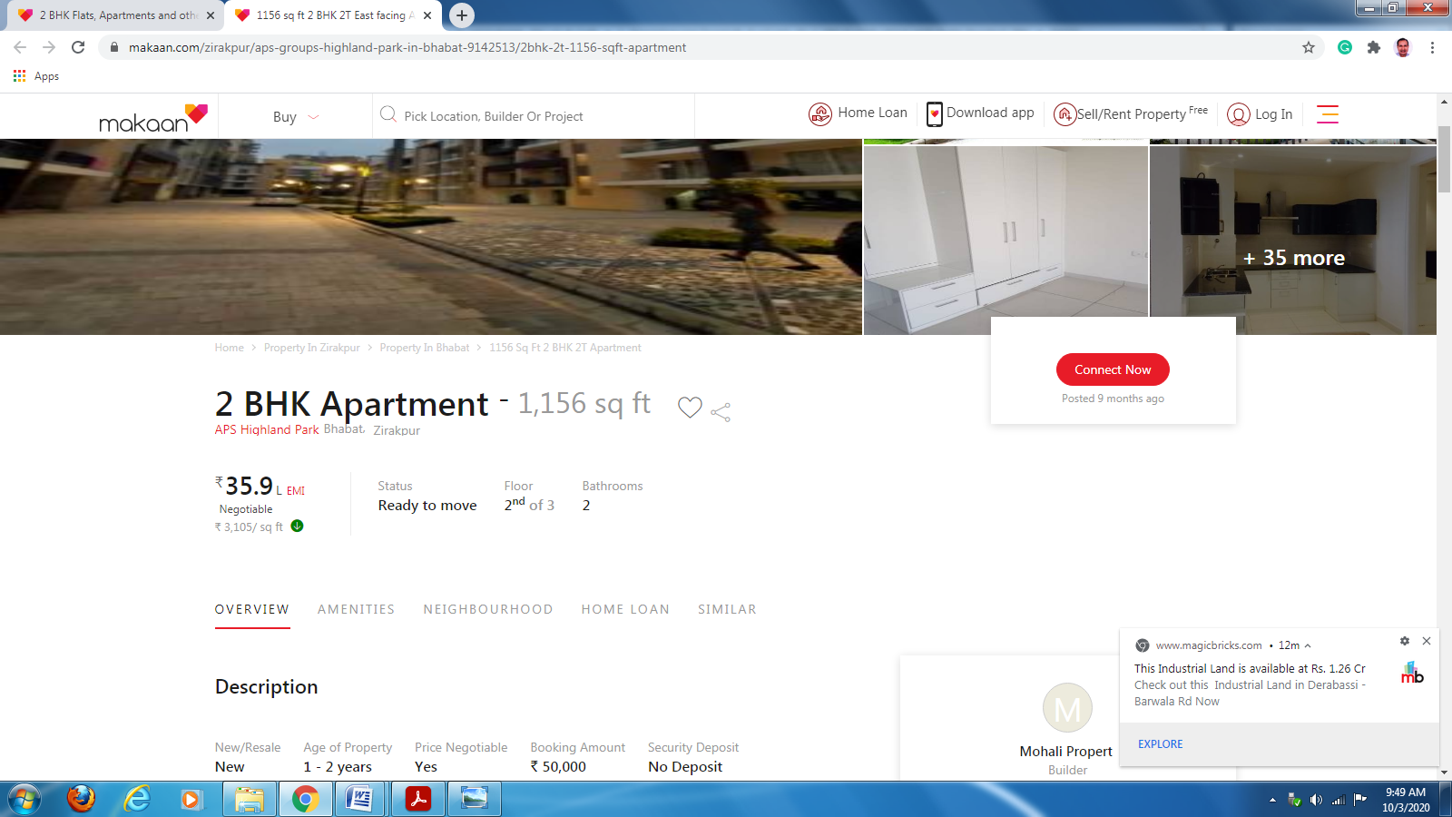

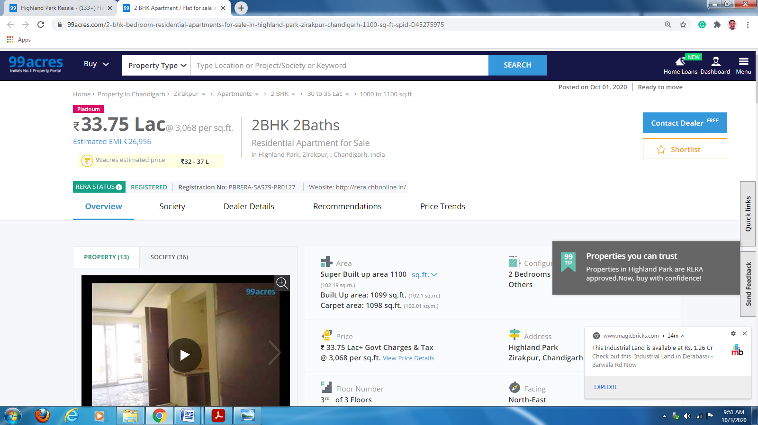

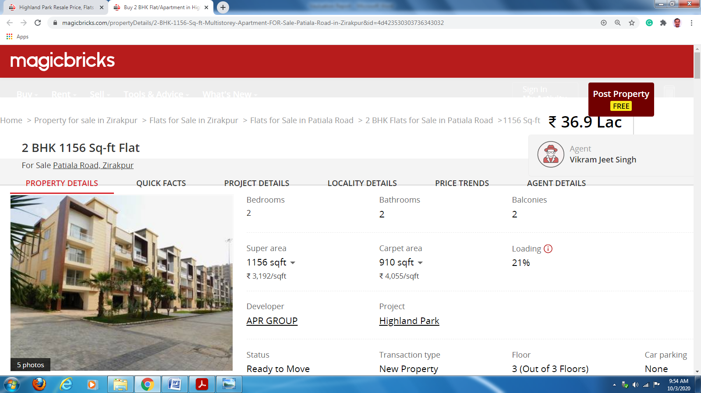

**COMPARATIVE ANALYSIS 2BHK , 1156 Sft. Flat in Highland Park, Bhabat, Zirakpur Distt. Mohali (PB).**

|  |  |  |  |  |  |  |  |
| --- | --- | --- | --- | --- | --- | --- | --- |
| **Sr. no.** | **Source of prices of property** | **Detail of property with age** | **Direction** | **Rate quoted in lacs** | **Adj. for area** | **Adj. for direction IN LAC** | **Net rate of property in lac** |
| 1 | Magicbricks.com | 2BHK of 1156 Sft. | - | 36.90 lac | NIL | - | 36.90 lac |
| 3 | 99acres.com | 2BHK of 1100 Sft. | - | 33.35 lac | NIL | - | 33.35 lac |
| 4 | Makaan.com | 2BHK of 1156 Sft | - | 35.90 lac | Nil | - | 35.90 lac |
| 5. | **Average price** | **(36.90+33.35+35.90)3 = 35.38 lac Say Rs.= 35.40 Lac** | | | | | |

**So present market value of Property is assessed Rs. 35.40 lac as on date and adopted for valuation .**

**Signature of Valuer**

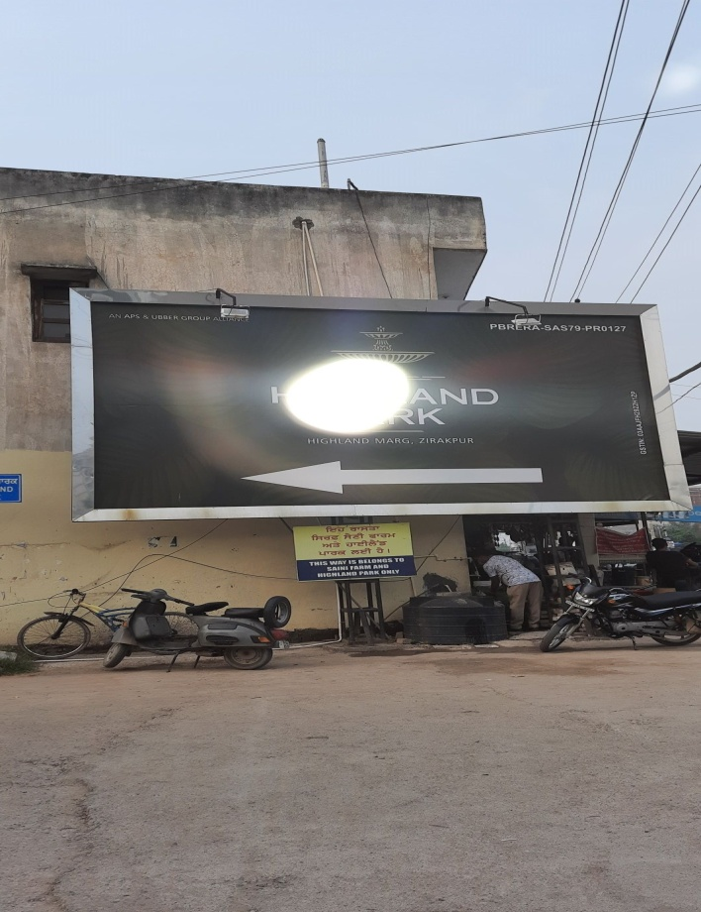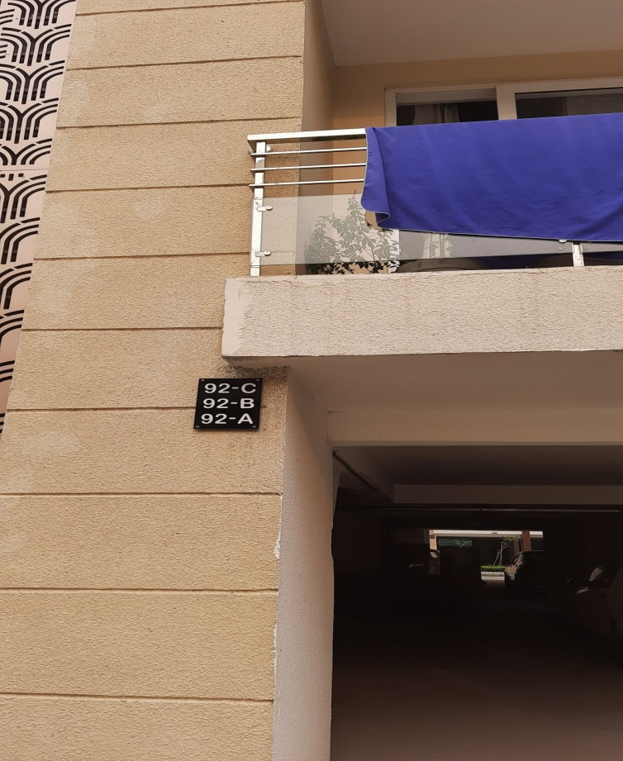

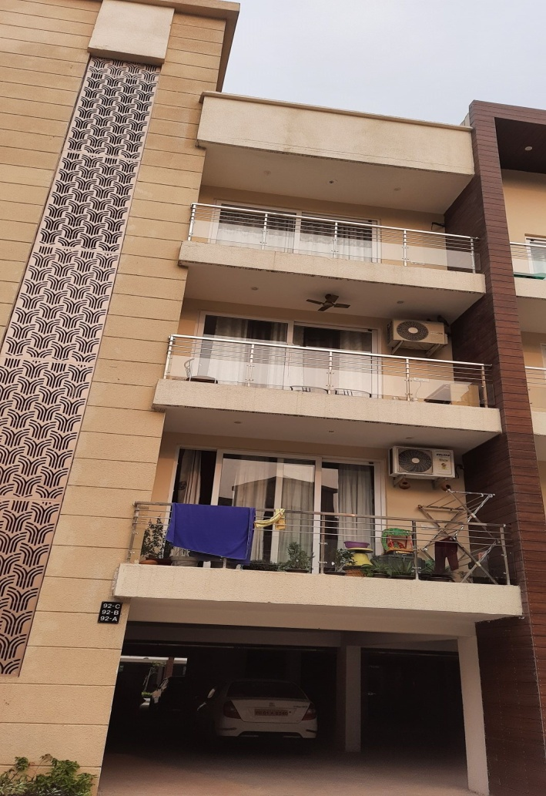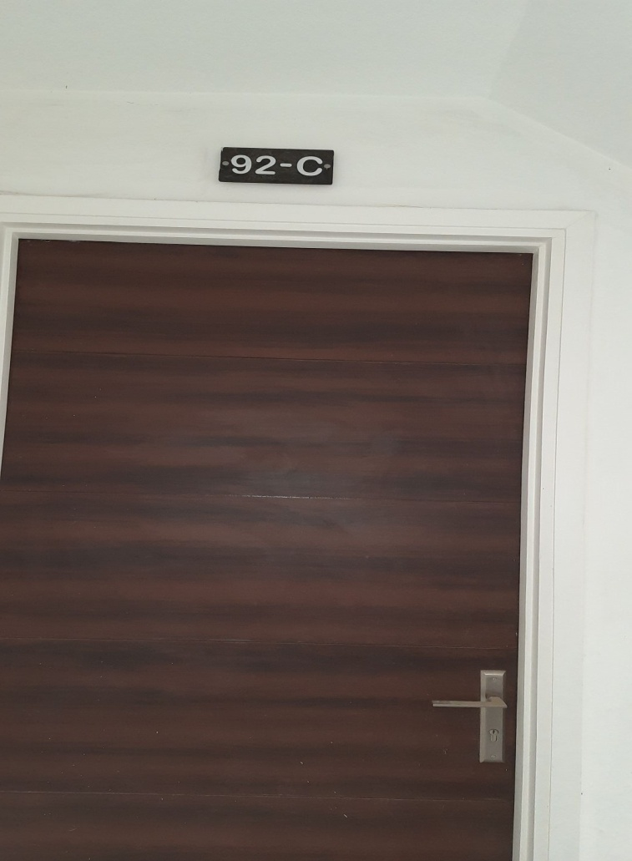

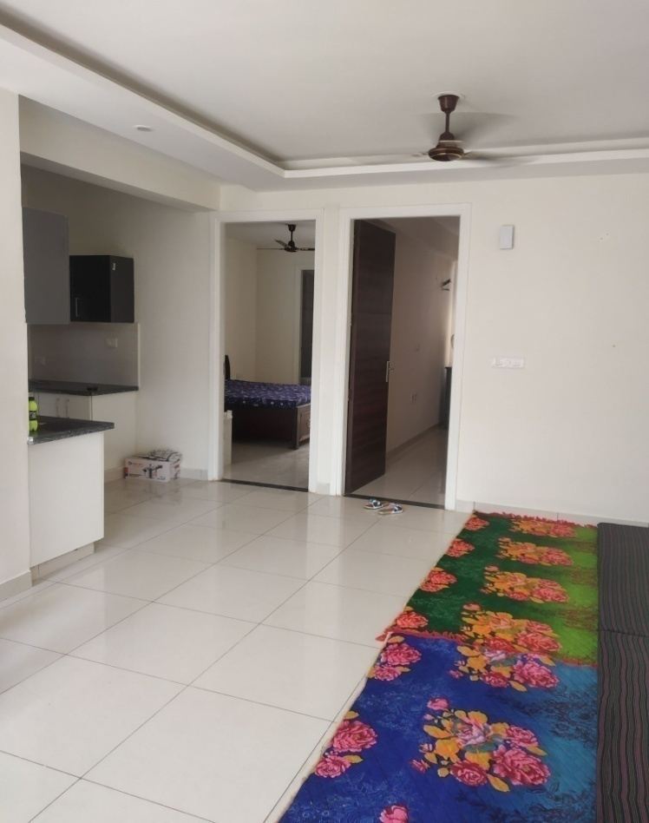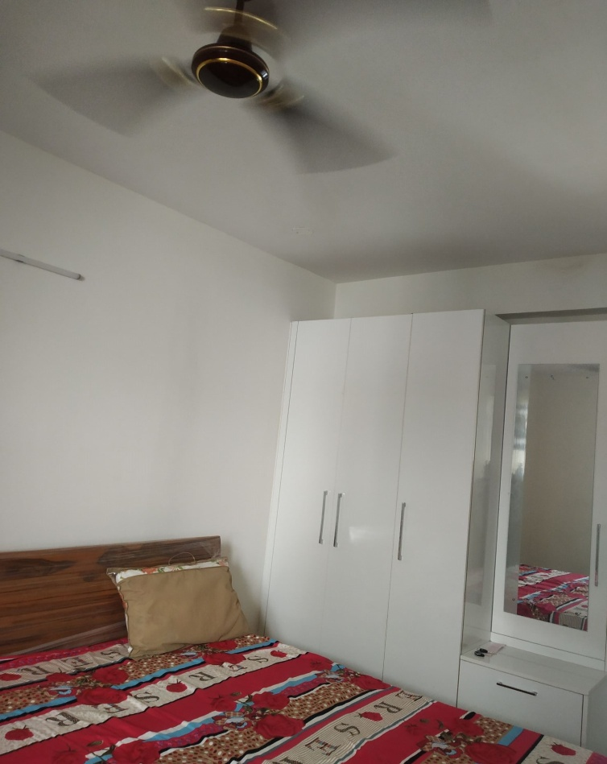

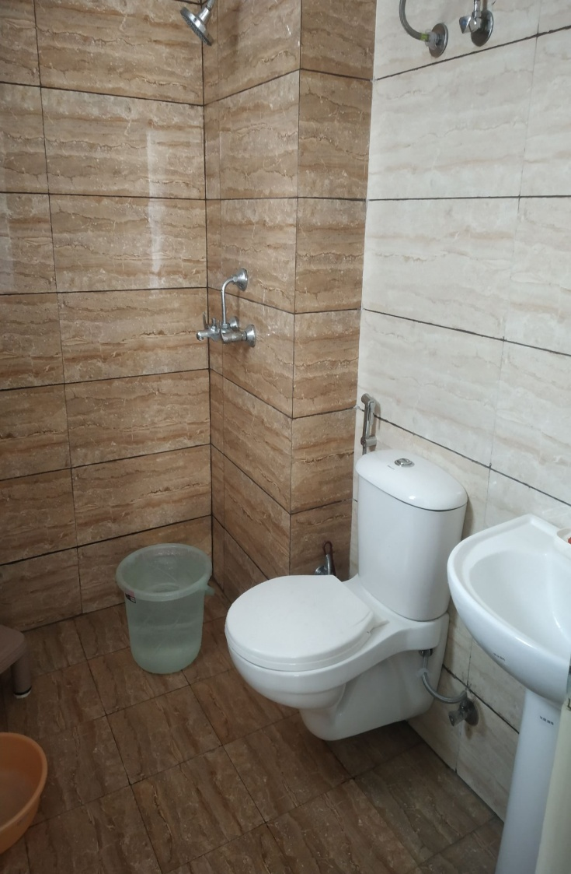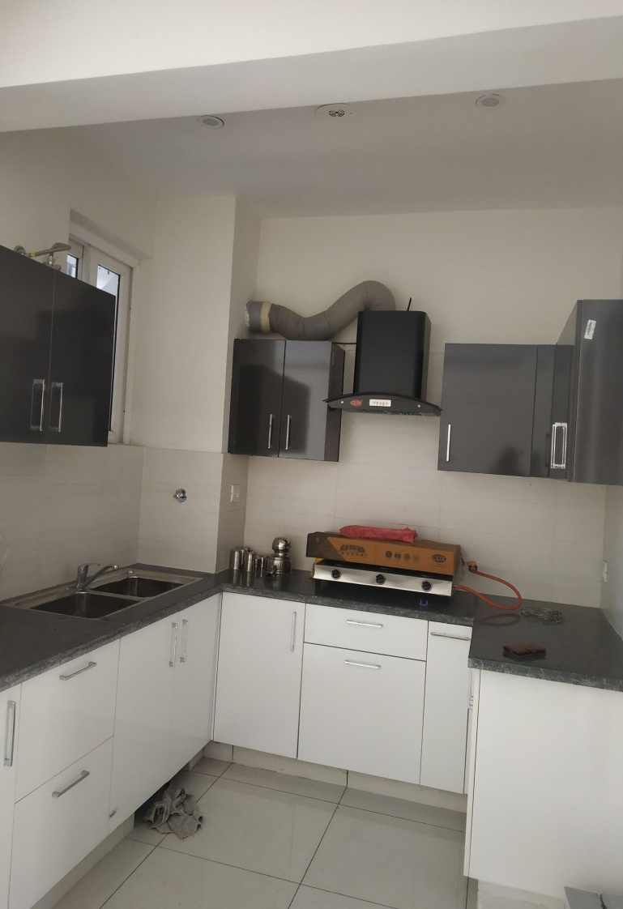

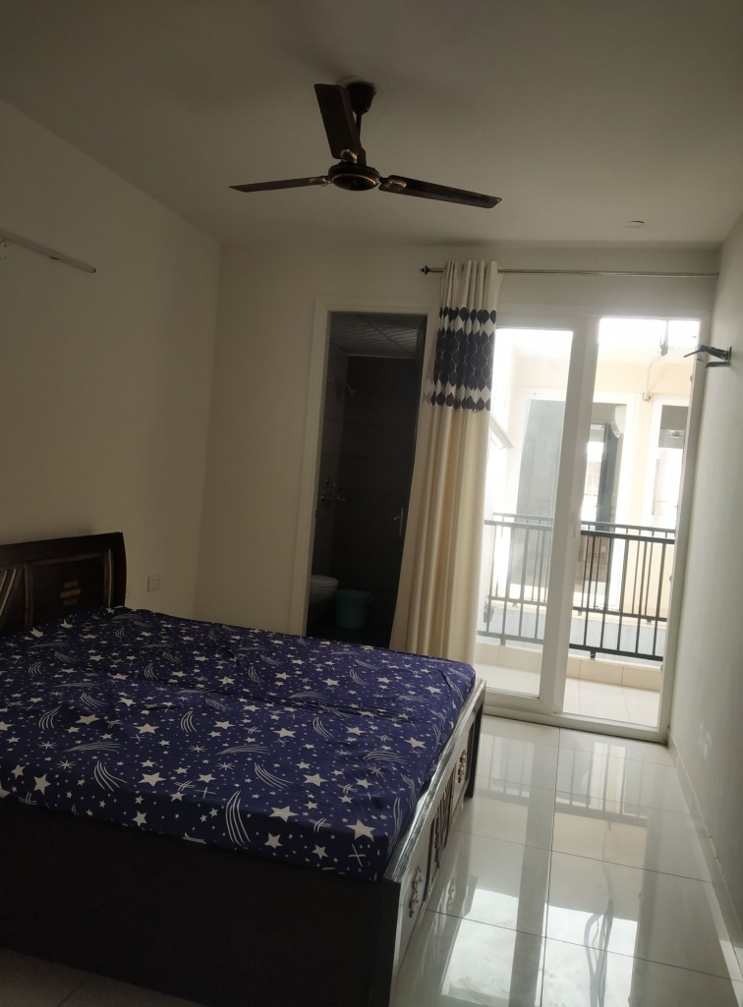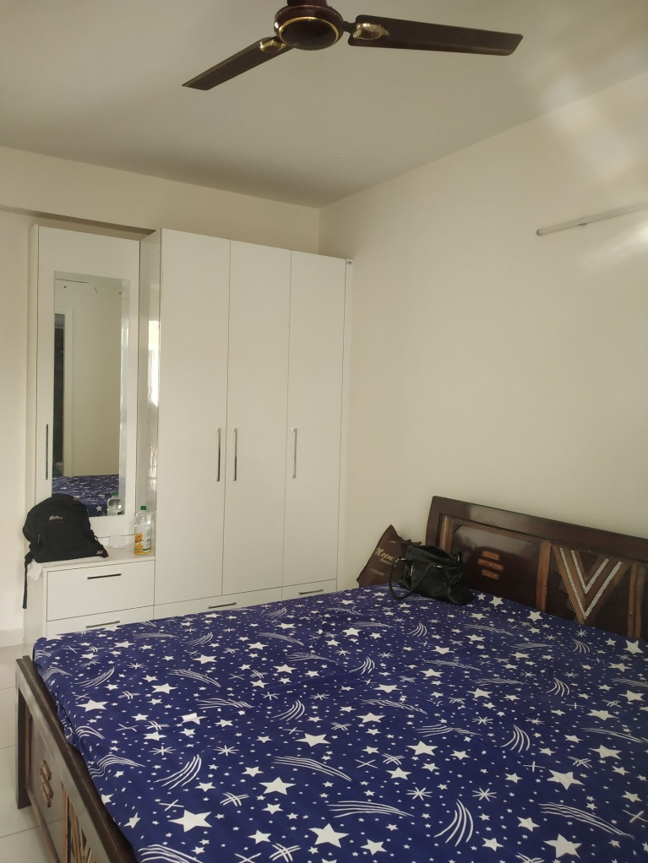

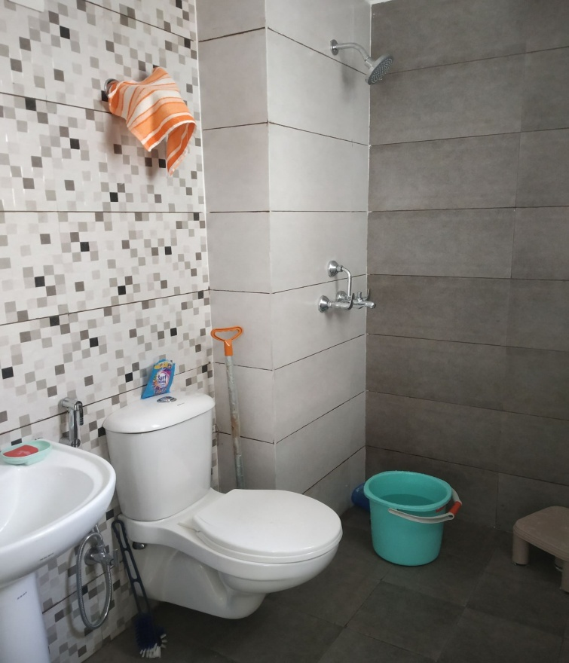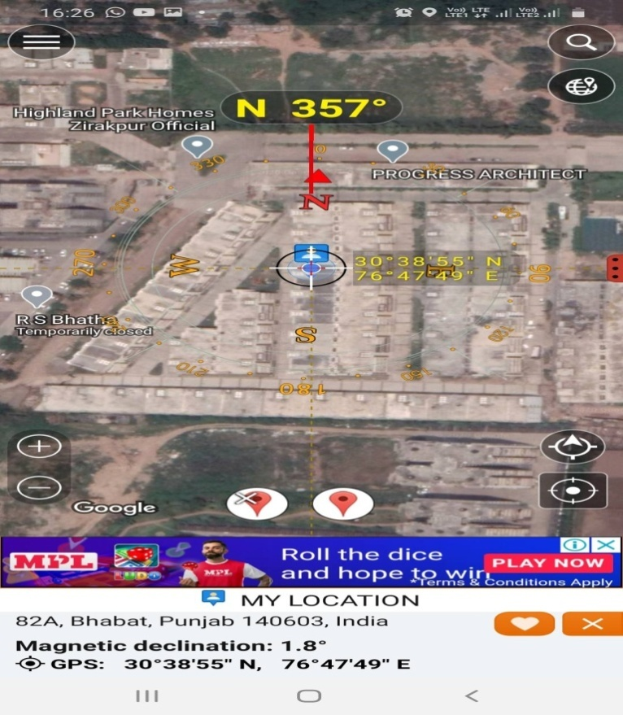

**Photos of the property have been attached as above**

**Google Location**

**Signature of Valuer**



**Download Docs**

**Signature of Valuer**



**Download Docs**

**Signature of Valuer**